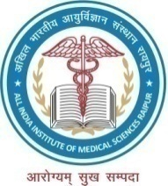
अखिल भारतीय आयुर्विज्ञान संस्थान, रायपुर (छत्तीसगढ़)
All India Institute of Medical Sciences Raipur (Chhattisgarh)
G. E. Road, Tatibandh,
Raipur-492 099 (CG)
www.aiimsraipur.edu.in

Admin/Rec./Project/Ych/ANAT/40/AIIMS.RPR Dated: 06.02.2020

Provisional result for the post of "Project Fellow" on contract basis under AIIMS Intramural Project “Testing of microdeletions of genes on Ychromosome in male partner of infertility cases” in AIIMS, Raipur.

Interview held on 03.02.2020 in the premises of AIIMS, Raipur.

Sr. No. | Name of candidate | Category | Remarks
1 | Ms. Lavanya M | UR | Selected
2 | Ms. Jyoti sahu | OBC | Wait List-1

